  - 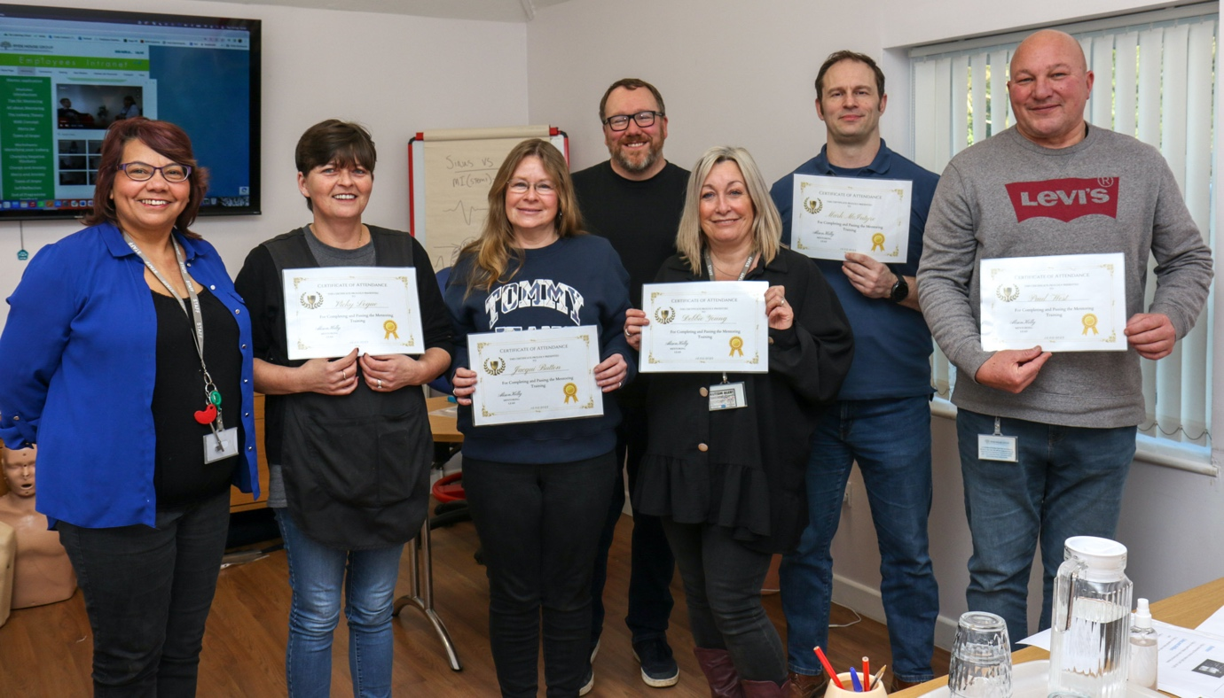
  - Please meet our mentoring team.

  - The mentoring program is a structured relationship between an experienced individual (the mentor) and a less experienced person (the mentee) to develop specific skills or knowledge. The mentor shares their expertise, knowledge, and experiences with the mentee to help them grow professionally or personally. The mentoring program typically has a defined duration, goals, and objectives and is designed to help the mentee improve their skills, knowledge, and overcome barriers that may be stopping them fulfilling an area in their lives or overcoming areas that are causing unwanted emotional, psychological or social barriers. The mentor provides guidance, feedback, and support to the mentee to help them achieve their goals and become more successful.

  - 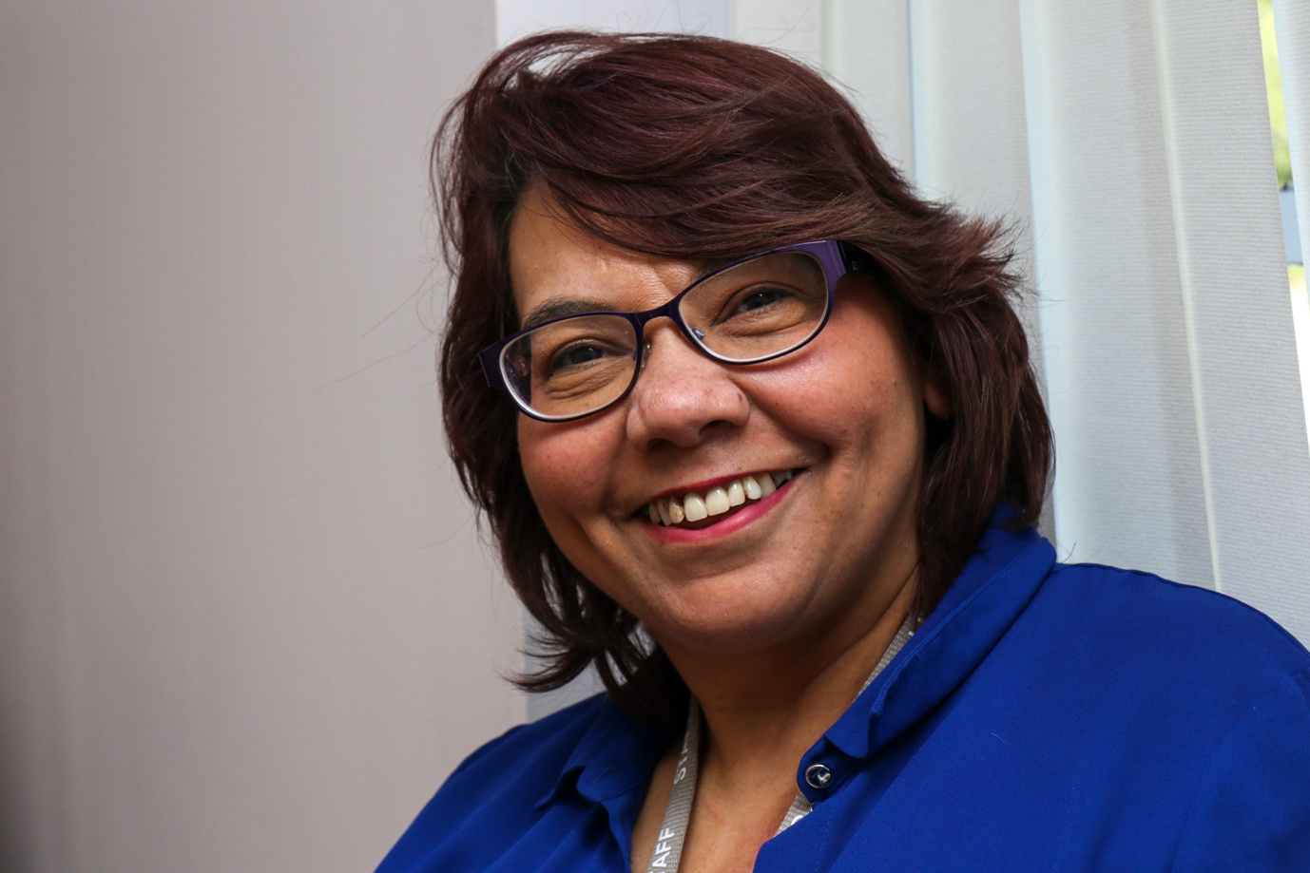
  - Alison Kelly

All About Me
Mentoring Lead
Hobbies
My hobbies are listening to music especially 60’s & 80’s
And reading books.
Likes and dislikes : I like to spend time with my friends. I like to have a nice meal out.
I don’t like snakes and I don’t like spinning around.
What kind of person am I and why I like working here.
People tell me I am friendly and always happy and smiling. I enjoy making others happy and that is why I like working here and love my job.

  - Paul West
  - 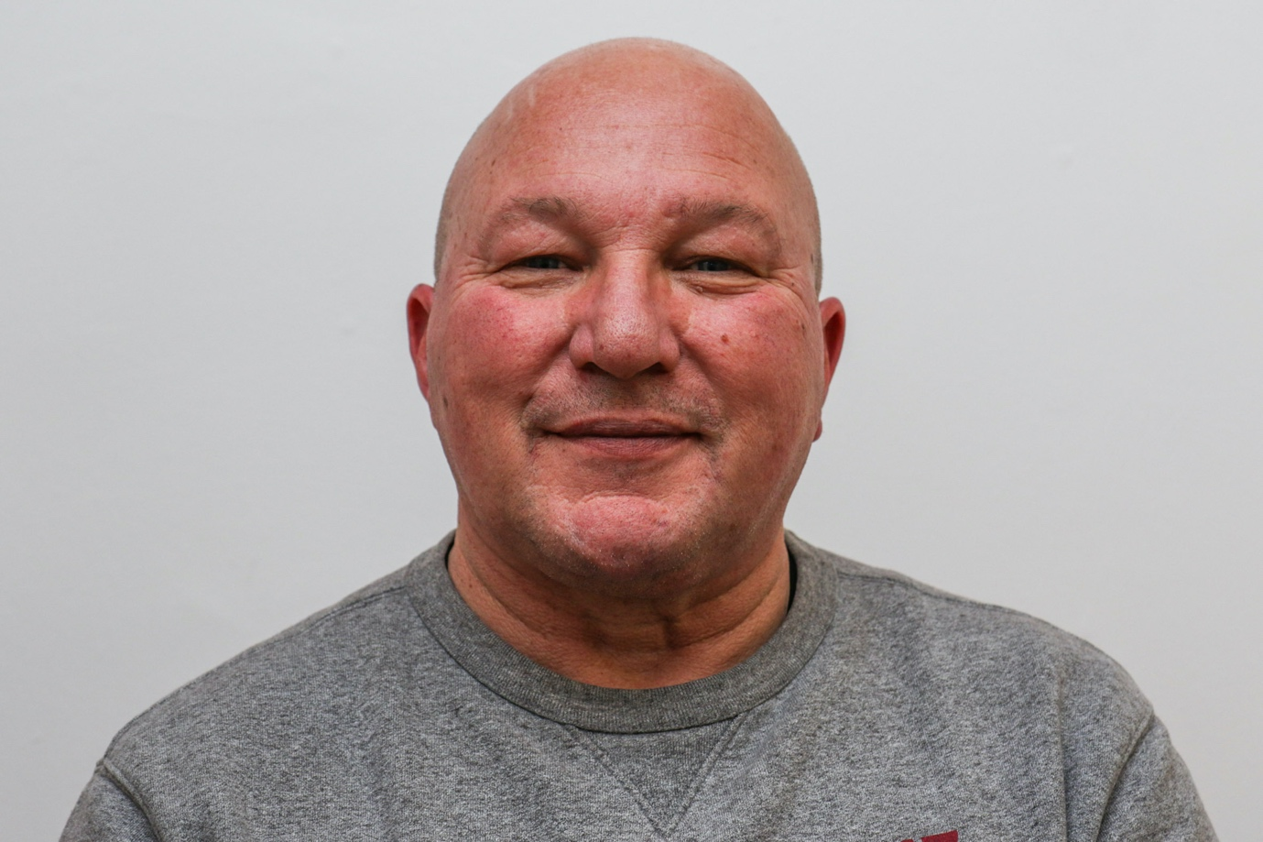

All About Me
Mentor
Hobbies
My hobbies are walking my dog and off-road dirt biking.
Likes and dislikes
I like to go on holiday.
I like to ride my dirt bike.
I don’t like mobile phones and cold rainy days.
What kind of person am I and why I like working here.
People tell me I am always smiling.
I enjoy making others happy and supporting others that is why I like working here and love my job.

Debbie Young
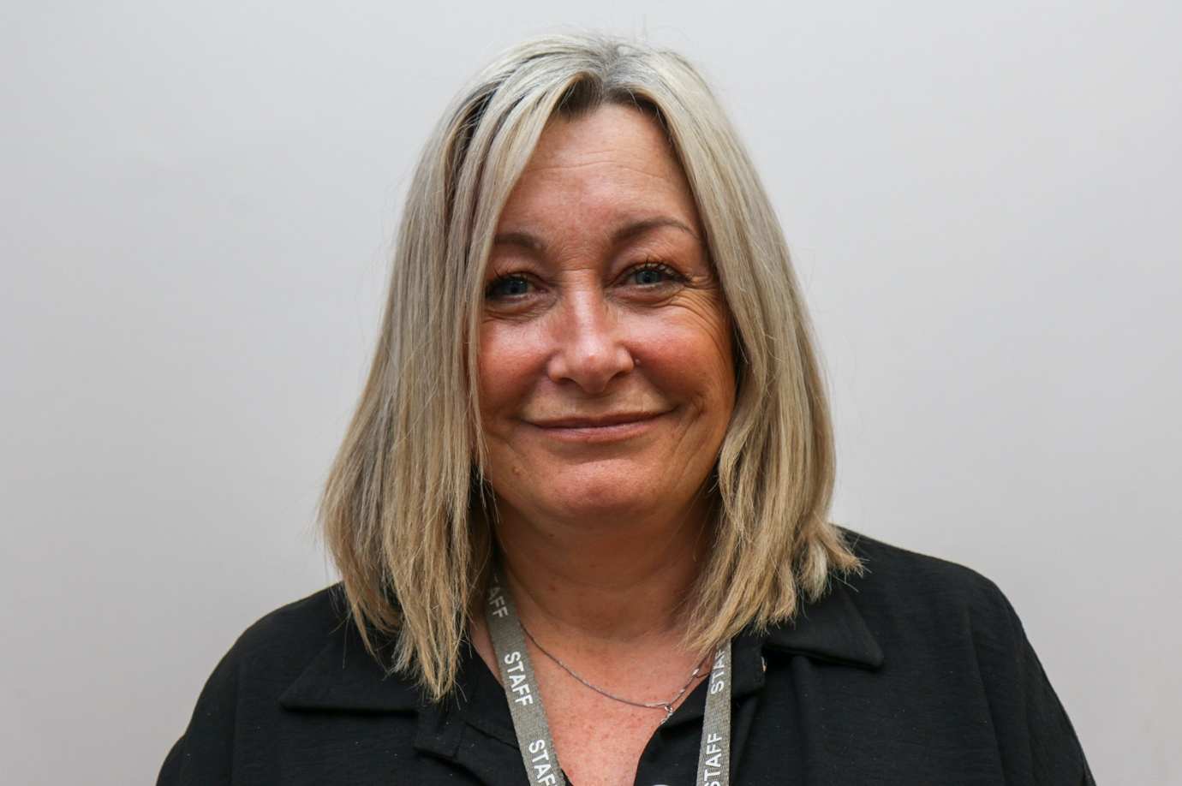

All About Me
Mentor
Hobbies
My hobbies are walking my dog (Oli) and spending quality time with friends and family.
Likes and dislikes
I like to read, and I like crystal art.
I don’t like lies and I don’t like birds.
What kind of person am I and why I like working here.
People tell me I am kind, hard working and I understand peoples feelings.

Vicky Logue

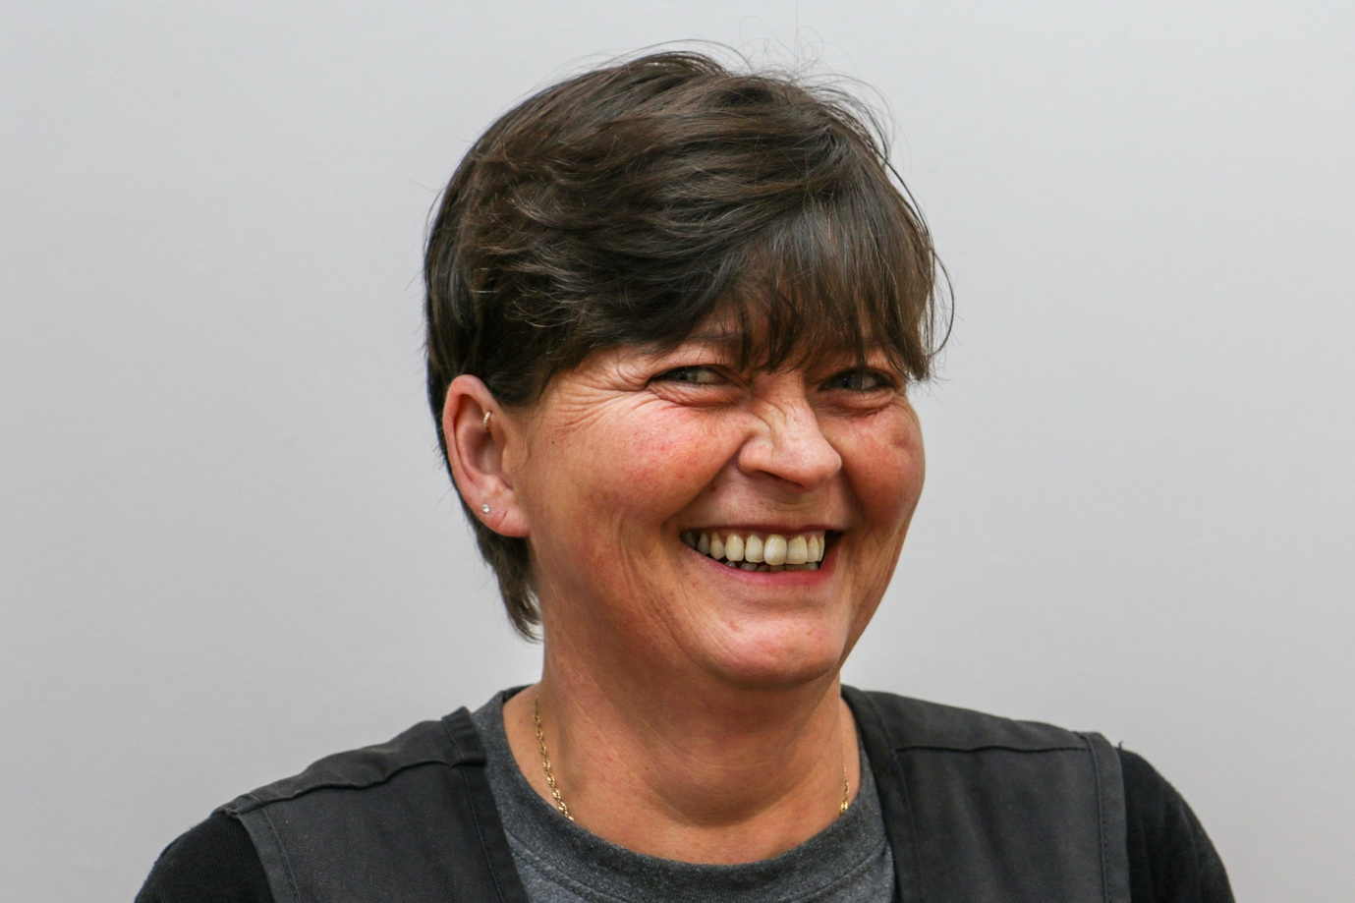

All About Me

Mentor
Hobbies
My hobbies are going out to eat in nice pubs and watching horror films.
Likes and dislikes : I like to relax at the weekends and spend time with my family.
I don’t like rude people or getting up early.
What kind of person am I and why I like working here.
People tell me I am easy going and I enjoy helping people and that is why I like working here and I love my job.

Jacquie Button

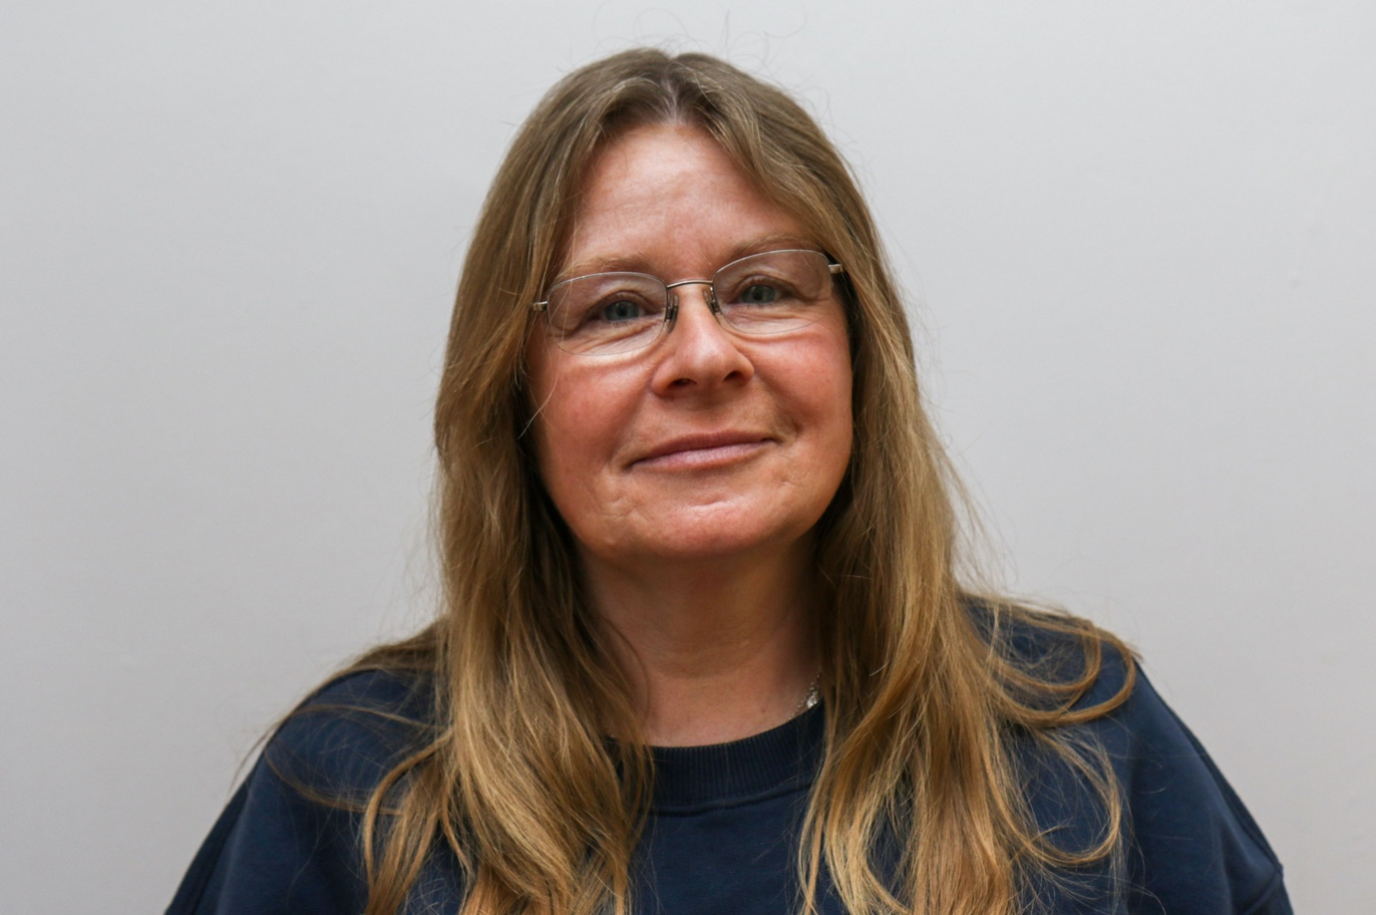

All About Me
Mentor
Hobbies
My hobbies are to go for walks and going to concerts.
Likes and dislikes
I like to listen to music, and I like to make a nice home.
I don’t like spiders and being cold.
What kind of person am I and why I like working here.
People tell me I am kind. I enjoy supporting and helping others that is why I like working here and I love my job.

Mark McIntyre

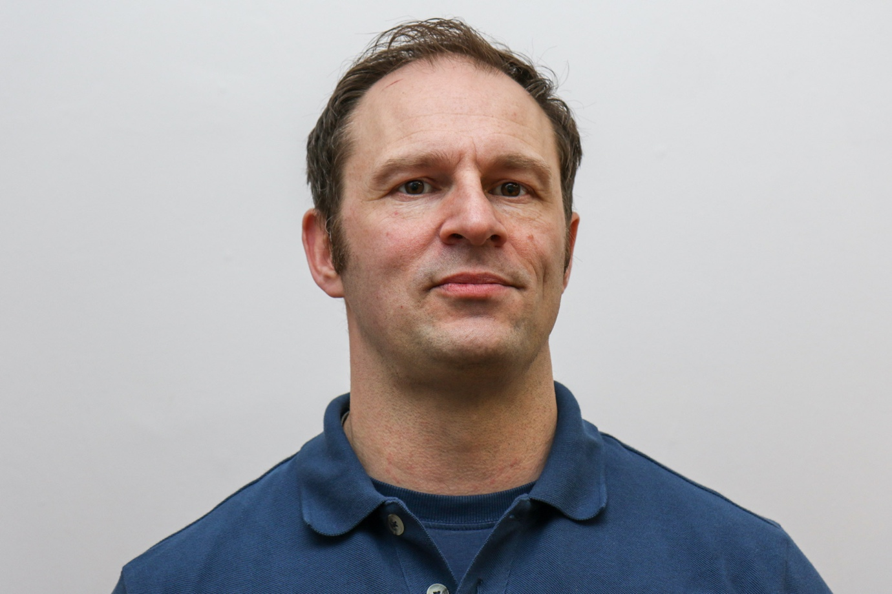
All About Me
Mentor
Hobbies
My hobbies are being outdoors and keeping active. I also watch movies.
Likes and dislikes
I like good food and I like hiking.
I don’t like spiders or mushrooms.
What kind of person am I and why I like working here.
People tell me I am funny, smart and a good dresser and always there for them.
I enjoy helping people and that is why I like working here and love my job.

